Types of Plate Boundaries Map Identification Directions B

- Lightly shade in each tectonic/lithospheric plate with a different color if possible.

- Use the table below and the Map Key on the “Types of Plate Boundaries Map” to draw the correct symbols identifying each type of plate boundary. The Nazca Plate has been completed on the map as an example.

- Once finished drawing boundary symbols, go back and draw arrows indicating the direction of plate movement at each boundary meeting point. The Nazca Plate has been completed on the map as an example.

- Guess the location of the Mid-Atlantic Ridge then check your answer with the teacher. If correct, label the location of the Mid-Atlantic Ridge on your map.

Plate Boundaries | Type of Boundary
Pacific Plate – Nazca Plate | Divergent
Pacific Plate – Cocos Plate | Divergent
From the top of Cocos Plate – Top of North American to the curve | Transform
Cocos Plate – North American Plate | Convergent
Cocos Plate – Caribbean Plate | Convergent
Caribbean – North American Plate | Transform
Cocos Plate – Nazca Plate | Divergent
Caribbean – South American Plate | Do Not Do
Nazca Plate – South American Plate | Convergent
Nazca Plate – Antarctic Plate | Divergent
South American Plate – Antarctic Plate | Do Not Do
South American Plate – African Plate | Divergent
North American Plate – African Plate | Divergent
North American Plate – Eurasian Plate | Divergent
African Plate – Antarctic Plate | Divergent
African Plate – Australian Plate | Divergent
African Plate – Indian Plate | Divergent
African Plate – Arabian Plate | Divergent
African Plate – Eurasian Plate | Convergent
Arabian Plate – Eurasian Plate | Convergent
Arabian Plate – Indian Plate | Transform
Indian Plate – Eurasian Plate | Convergent
Australian Plate – Eurasian Plate | Convergent
Pacific Plate – Eurasian Plate | Convergent

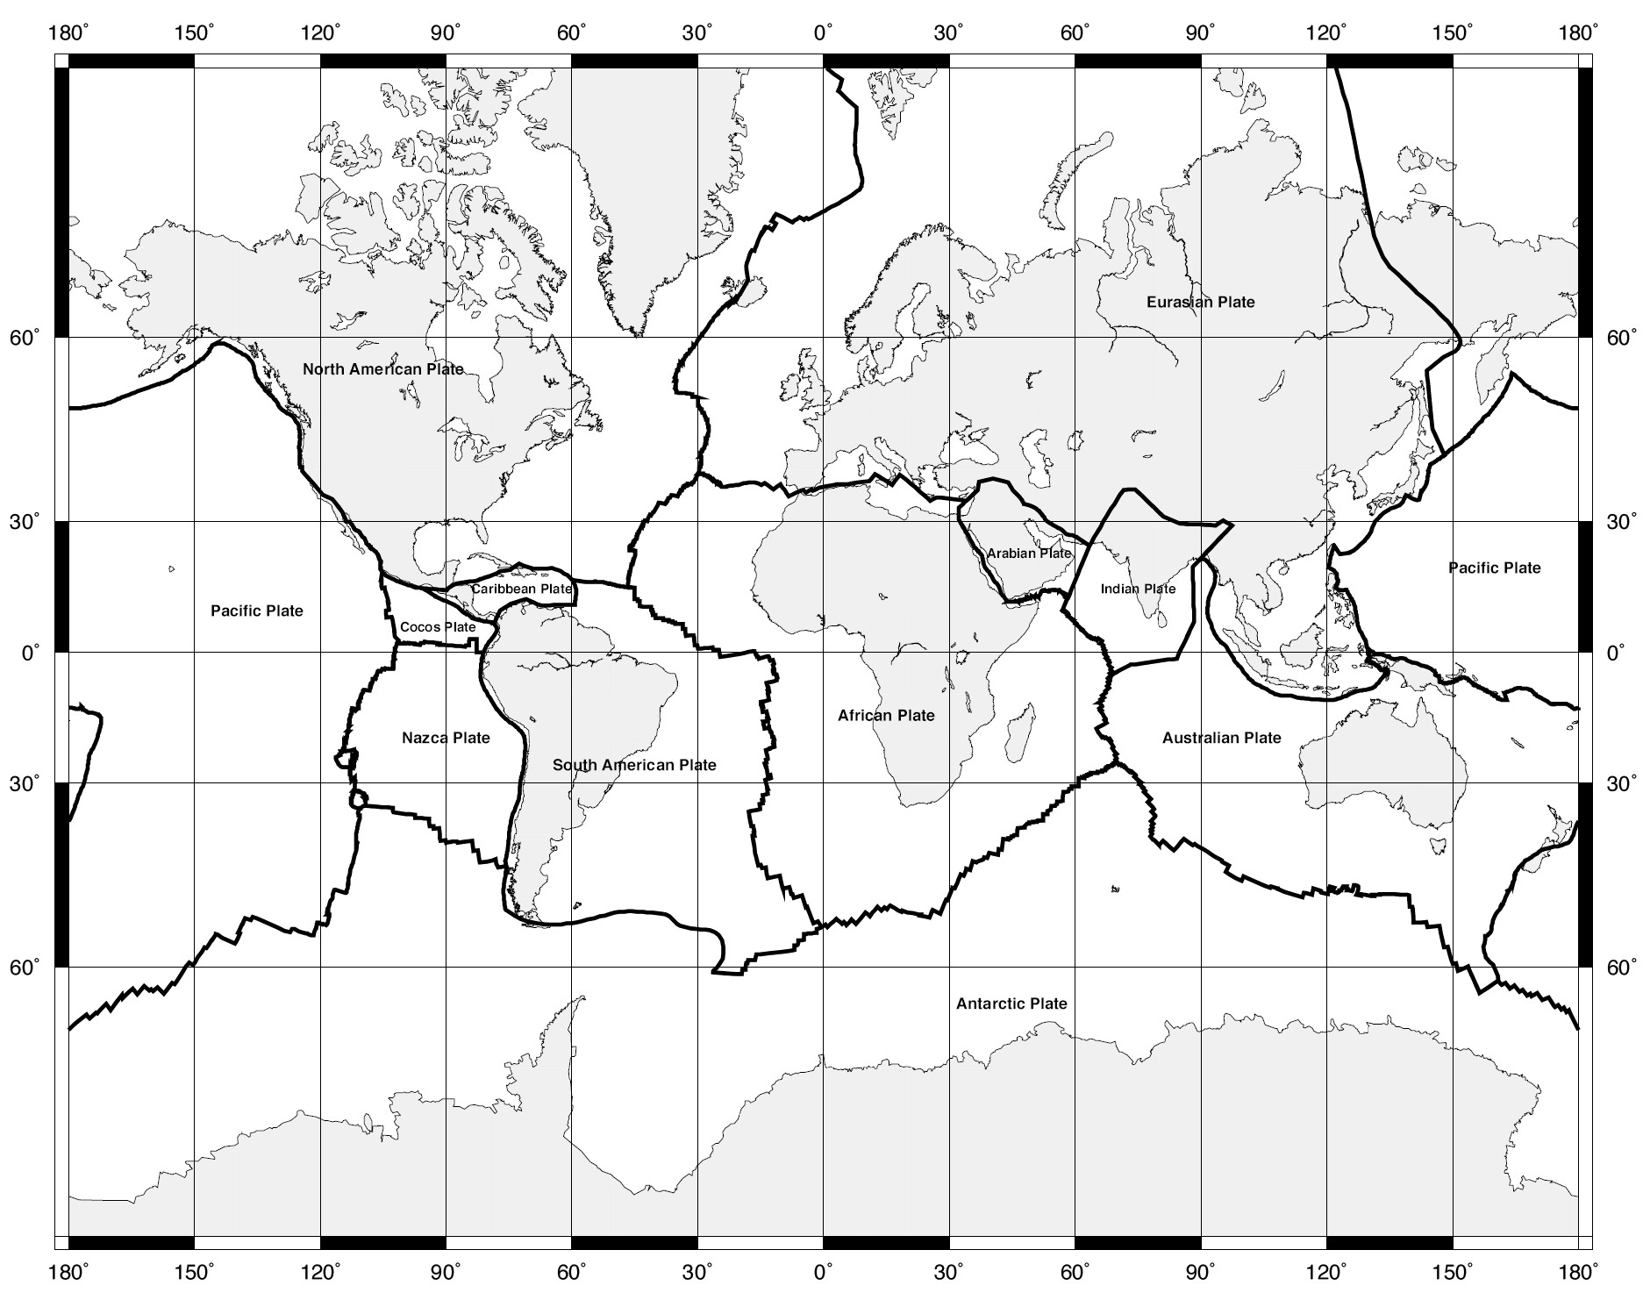Types of Plate Boundaries Map Identification B Name Date
Type of Plate
Boundary Key:

Divergent Boundary
Convergent Boundary
Transform
Boundary
X
Why do more volcanoes form along the boundaries of the Pacific Plate?

Types of Plate Boundaries Map Identification

